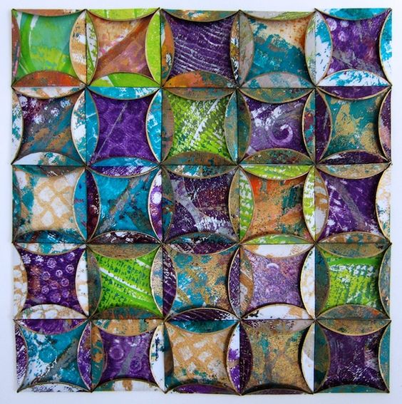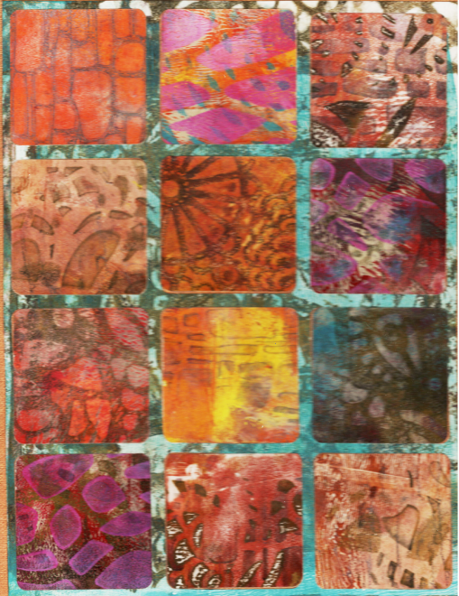

* **WHO: First time students and repeat students are all going to enjoy this class.**
* **WHERE: The Sewing Labs (new location at 27th & Tracy)**
* **WHEN: Saturday, June 9th**
* **TIME: 1pm – 5pm**
* **COST: $25 for the workshop; kits are available for an additional $20**
* **We will be using Gelli-Art printing plates, stencils , rubber stamps and paints to create gorgeous papers . We will then use these papers to make “paper quilts” that are suitable for framing.**
* **If you already have a Gelli-plate bring it. And if you want to buy one we have those kits available. Here’s a website to see what gelli-printing is about:** [**www.gelliarts.com**](http://www.gelliarts.com)
* **If you have a circle or a square punch, bring it along**
* **You will learn lots of NEW techniques to create your artwork. You will fall “head over heels” in love with your creations!**
* **In addition to creating paper quilts, we will enjoy a sense of community with special activities throughout the afternoon for sharing from the Heart.**
* **Limited to 12 participants. RSVP at:** [**operations@TheSewingLabs.community**](mailto:operations@TheSewingLabs.community)